MA 303: Final Exam Practice Problems

# Problems from Midterm 1:

These problems will be multiple choice. There will be two or three problems from this section. I would rather focus on the last section than this section, but still need to review these.

## Section 5.1: Review of Power Series

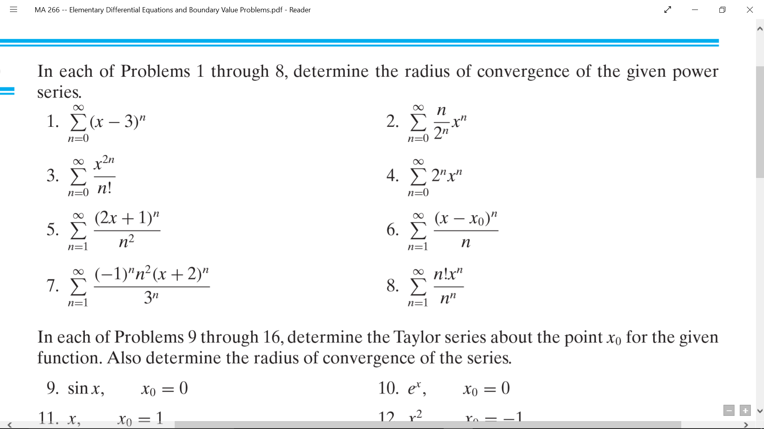

### #3



### #7



## Section 5.2: Series Solutions Near an Ordinary Point, Part I

### 

### #7

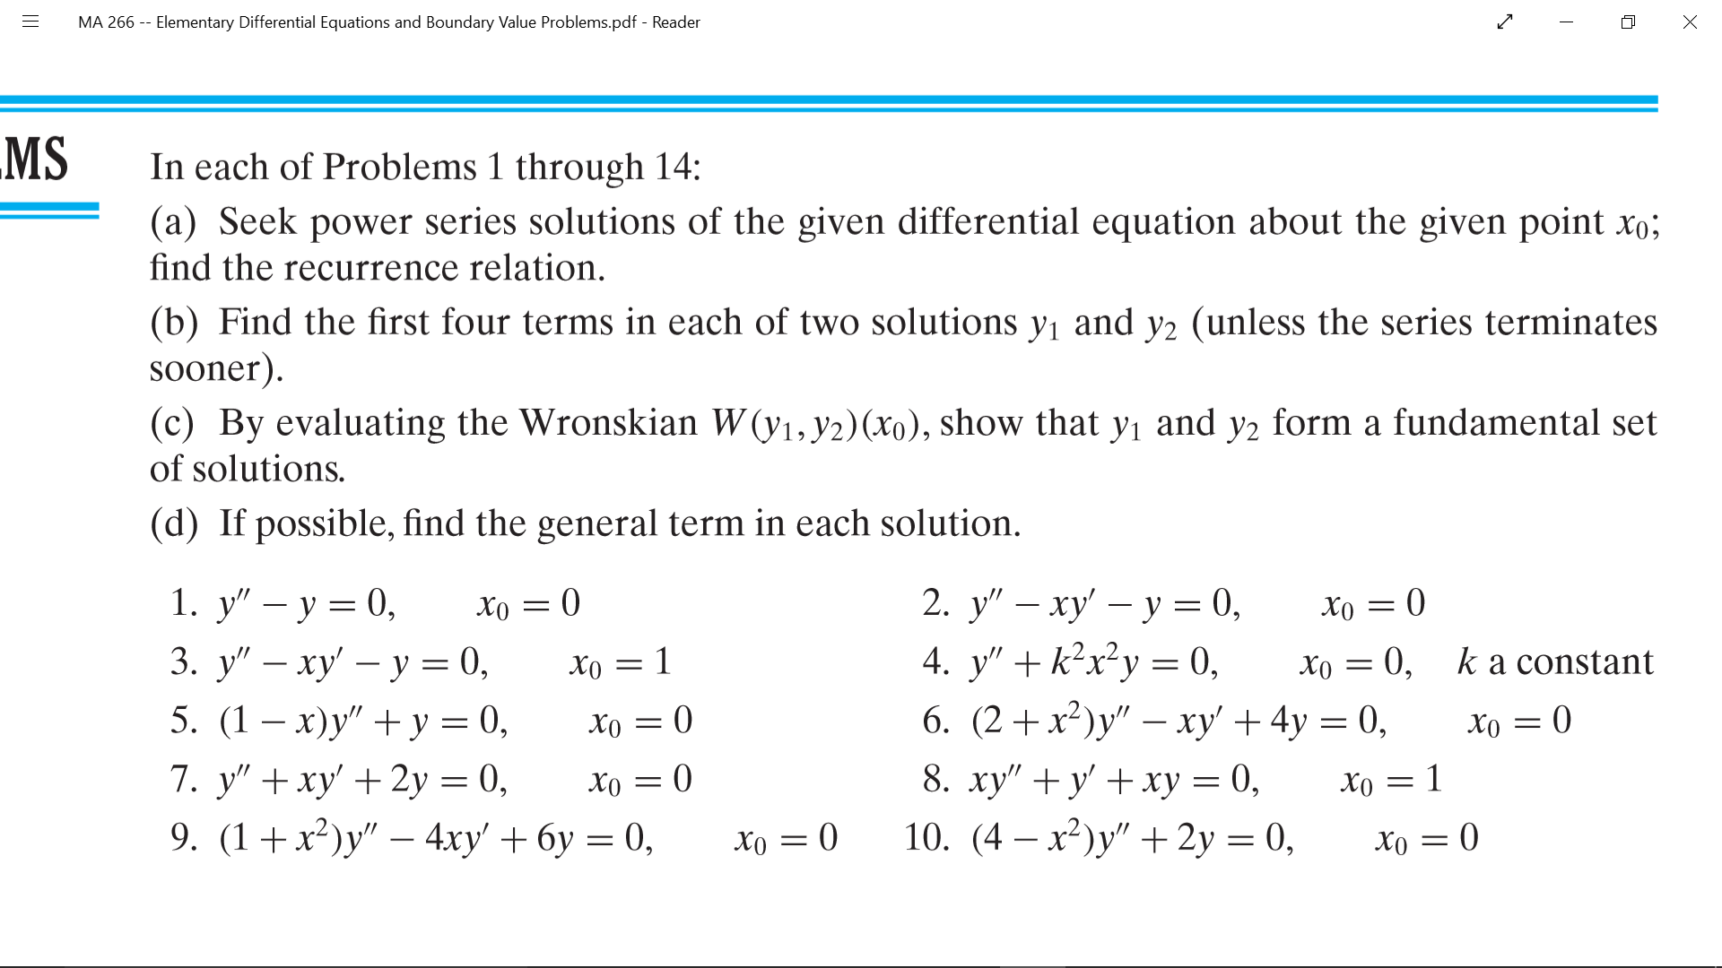

## Section 5.3: Series Solutions Near an Ordinary Point, Part II

### 

### #7

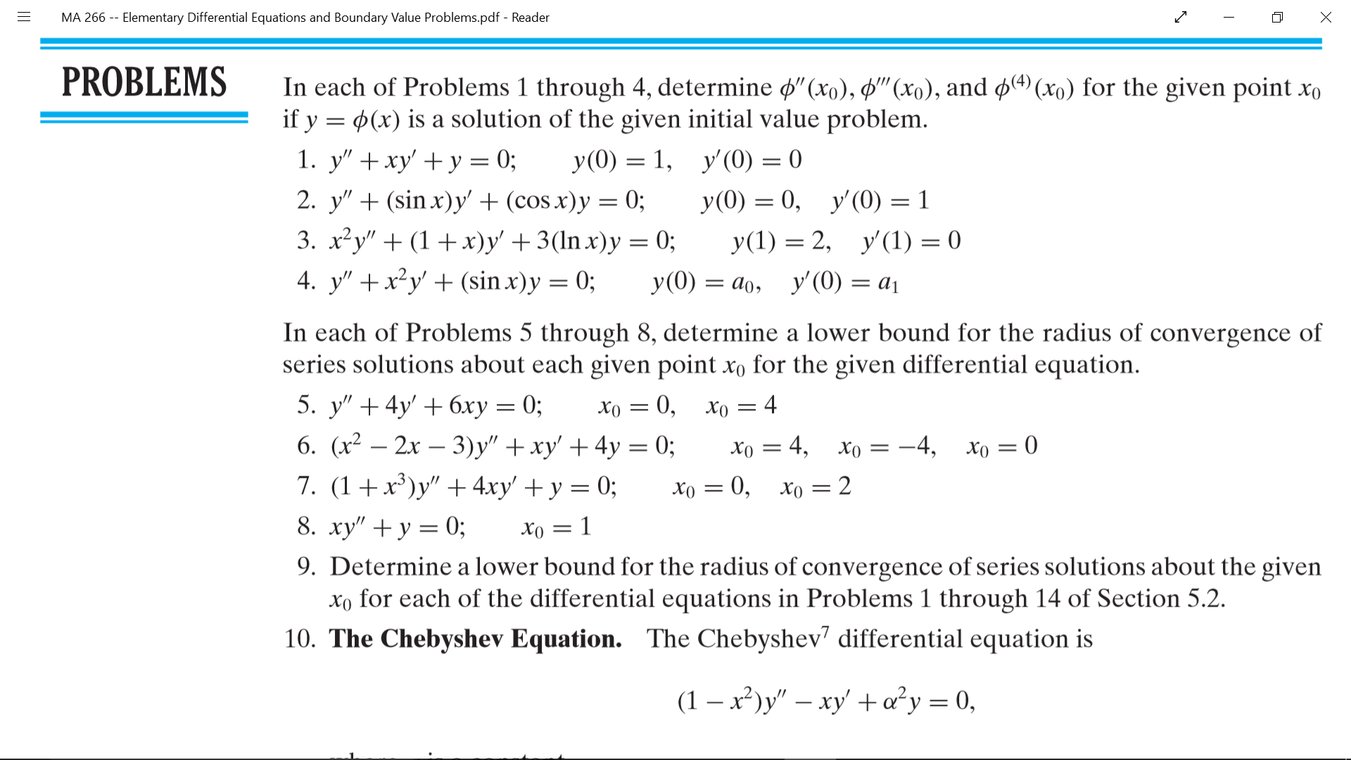

## Section 5.4: Series Solutions of Second Order Linear Equations

### 

### #7

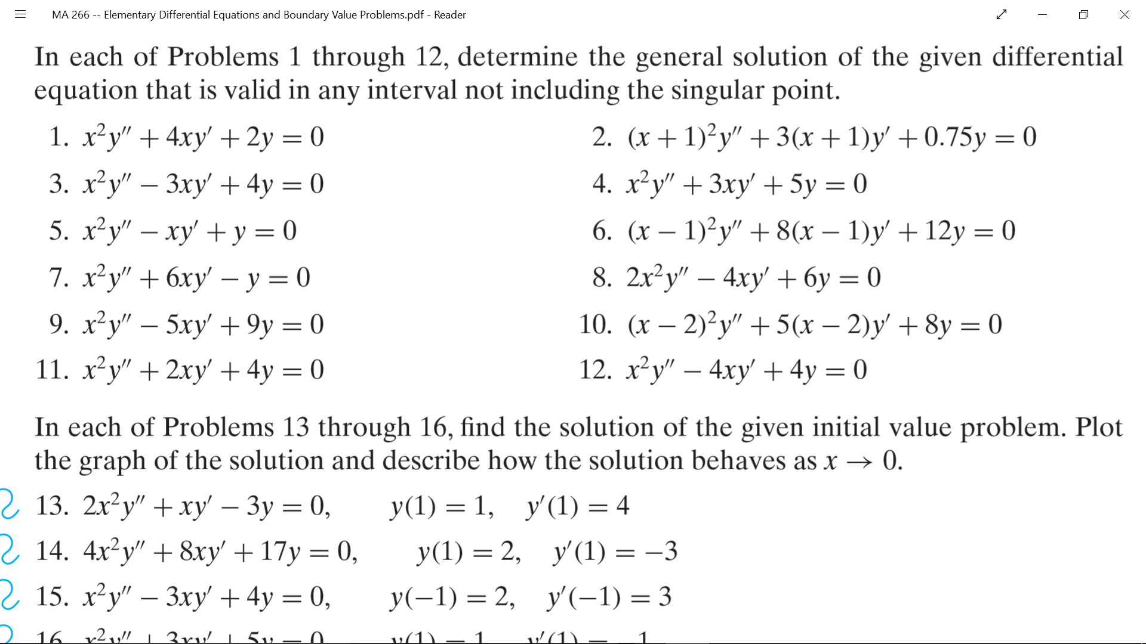

### #10



____________________________________________________________________________

### 

### #19

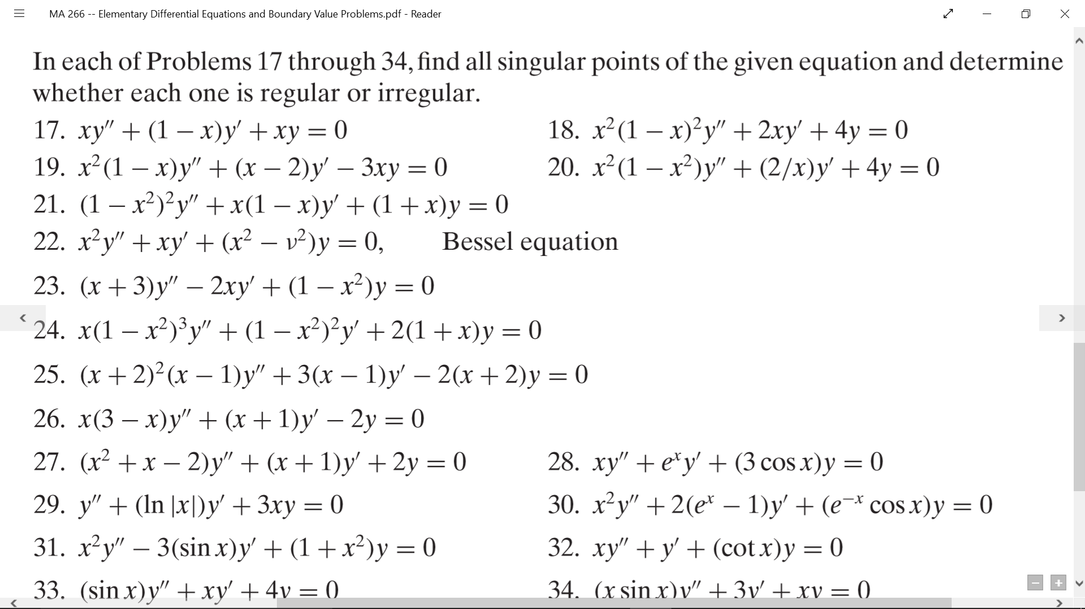

### #25



## Section 5.5: Series Solutions Near a Regular Singular Point, Part I

### 

### #6

### 

### 

# Problems from Second Midterm:

These problems will be multiple choice. There will be two or three problems from this section. Since we worked with these last time, I feel really good about them & don’t think we need to review them again. I will practice them on my own time.

# Problems from End of Semester:

These problems will be free response. There will be five questions from this section. I would rather focus on these rather than the other two midterms since there are more points from this section.

## Section 10.1: Two-Point Boundary Value Problems

### 

### #14

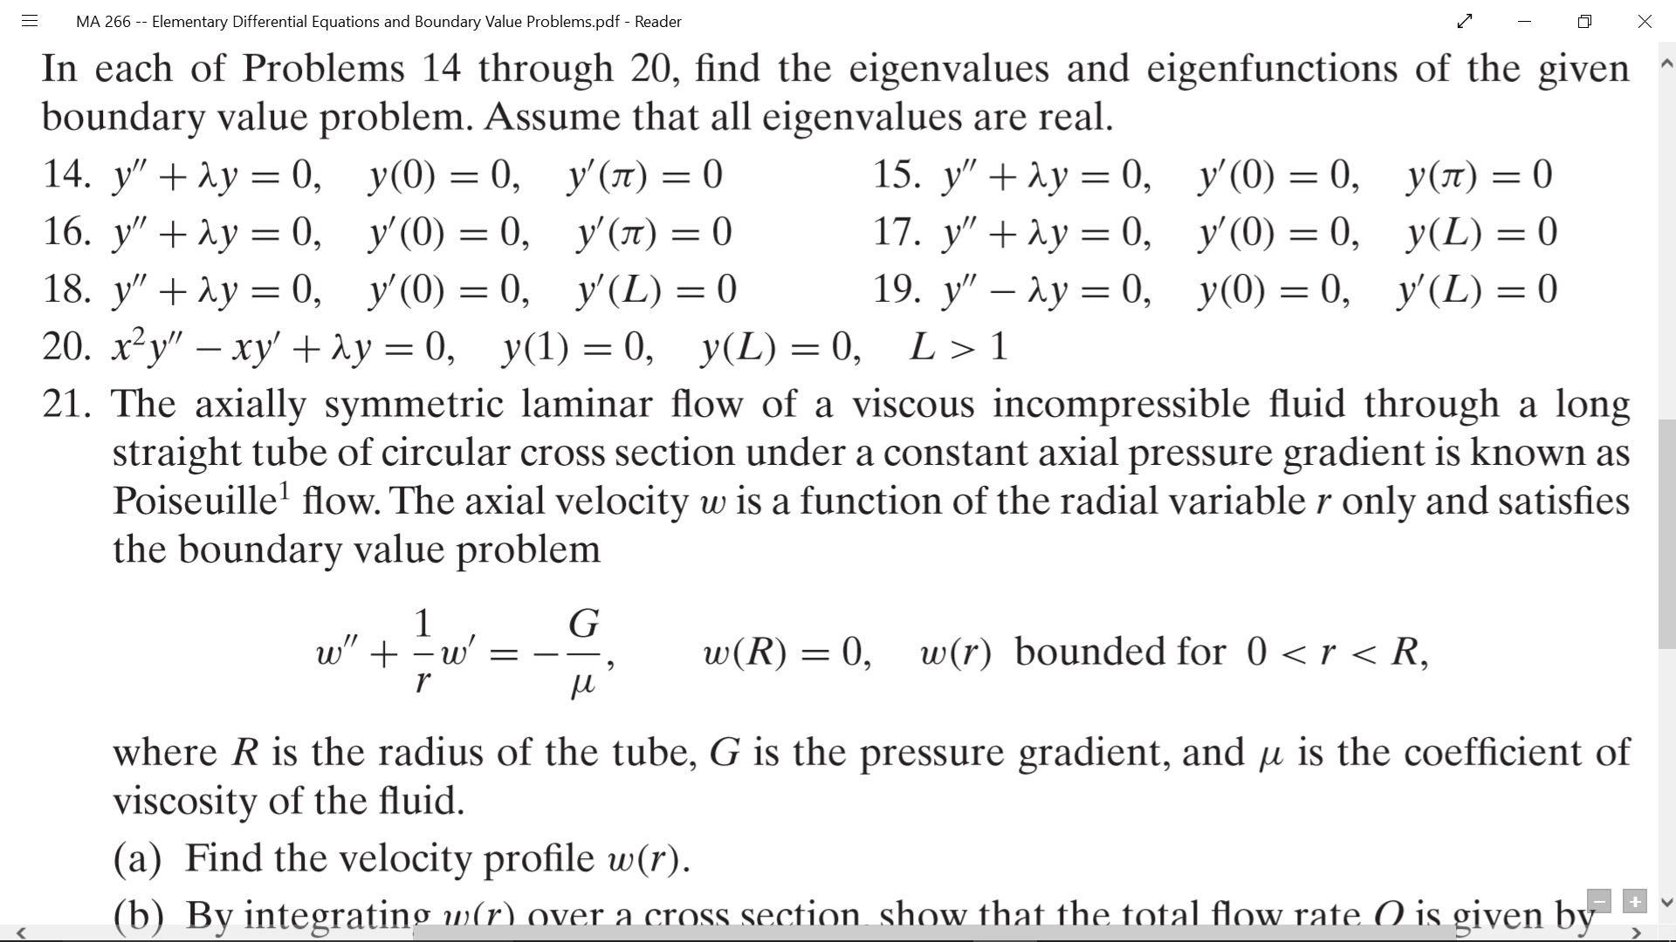

### #18



## Section 10.2: Fourier Series

### 

### #18

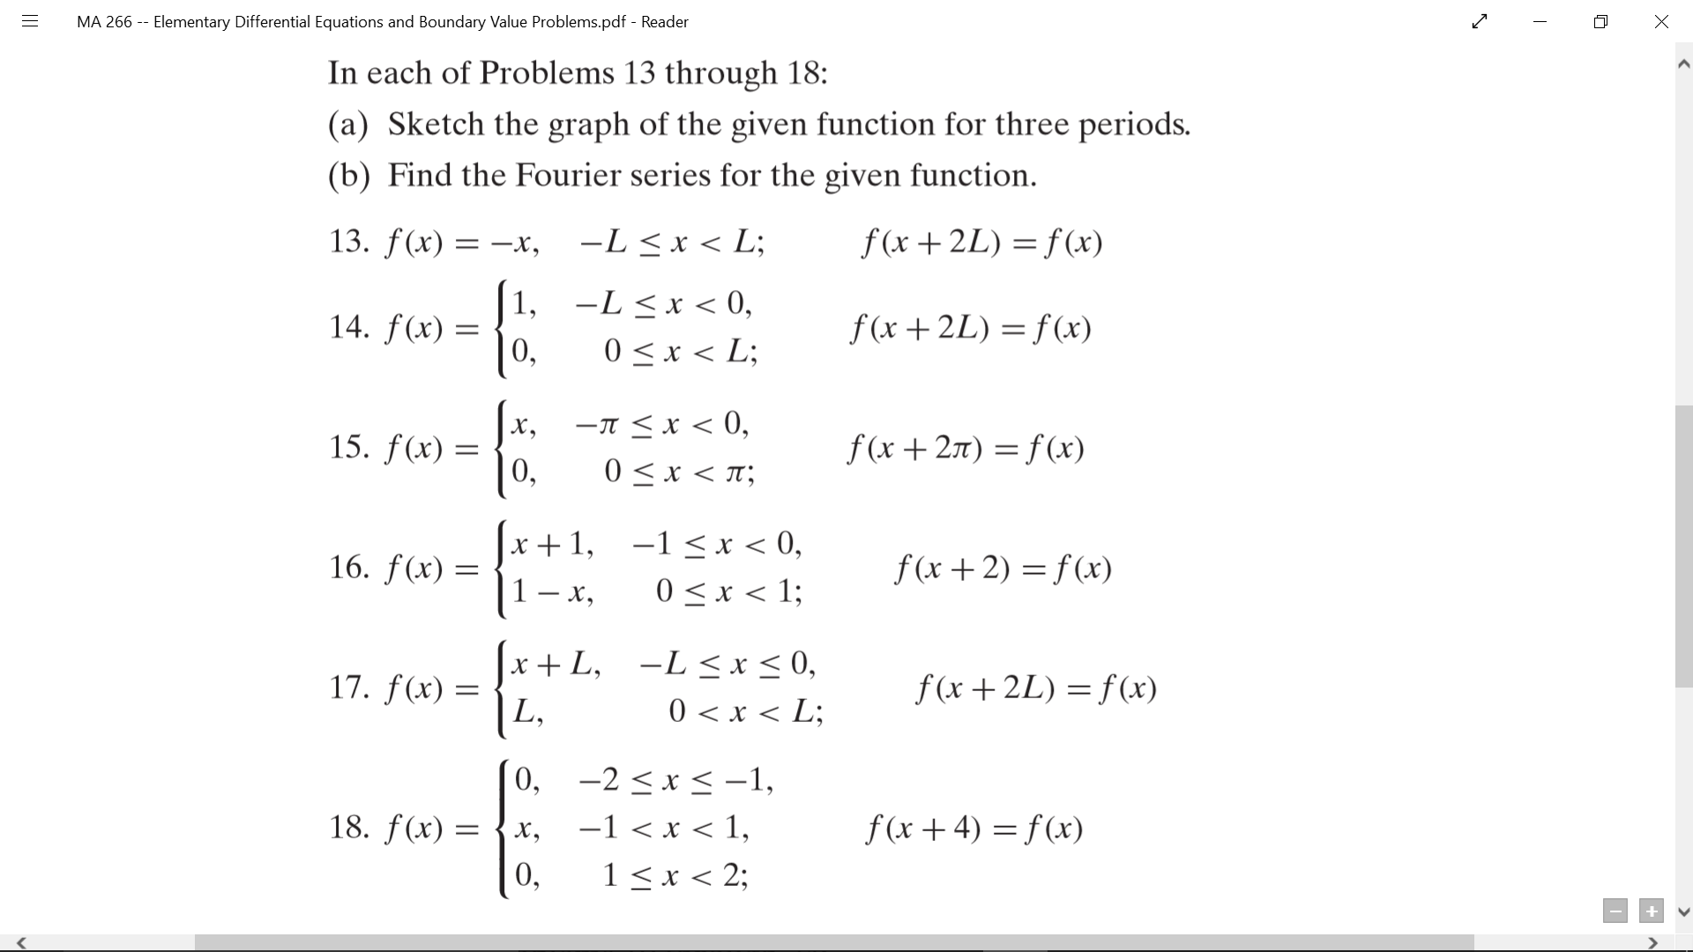

## Section 10.3: The Fourier Convergence Theorem

### 

### #1

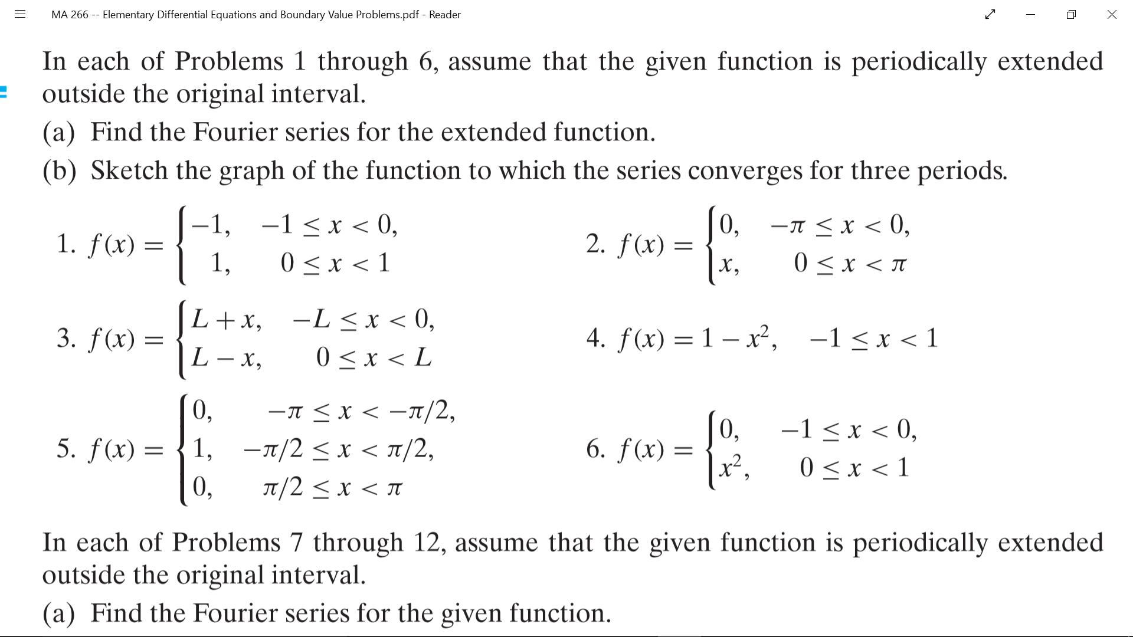

## Section 10.4:

### 

### #7

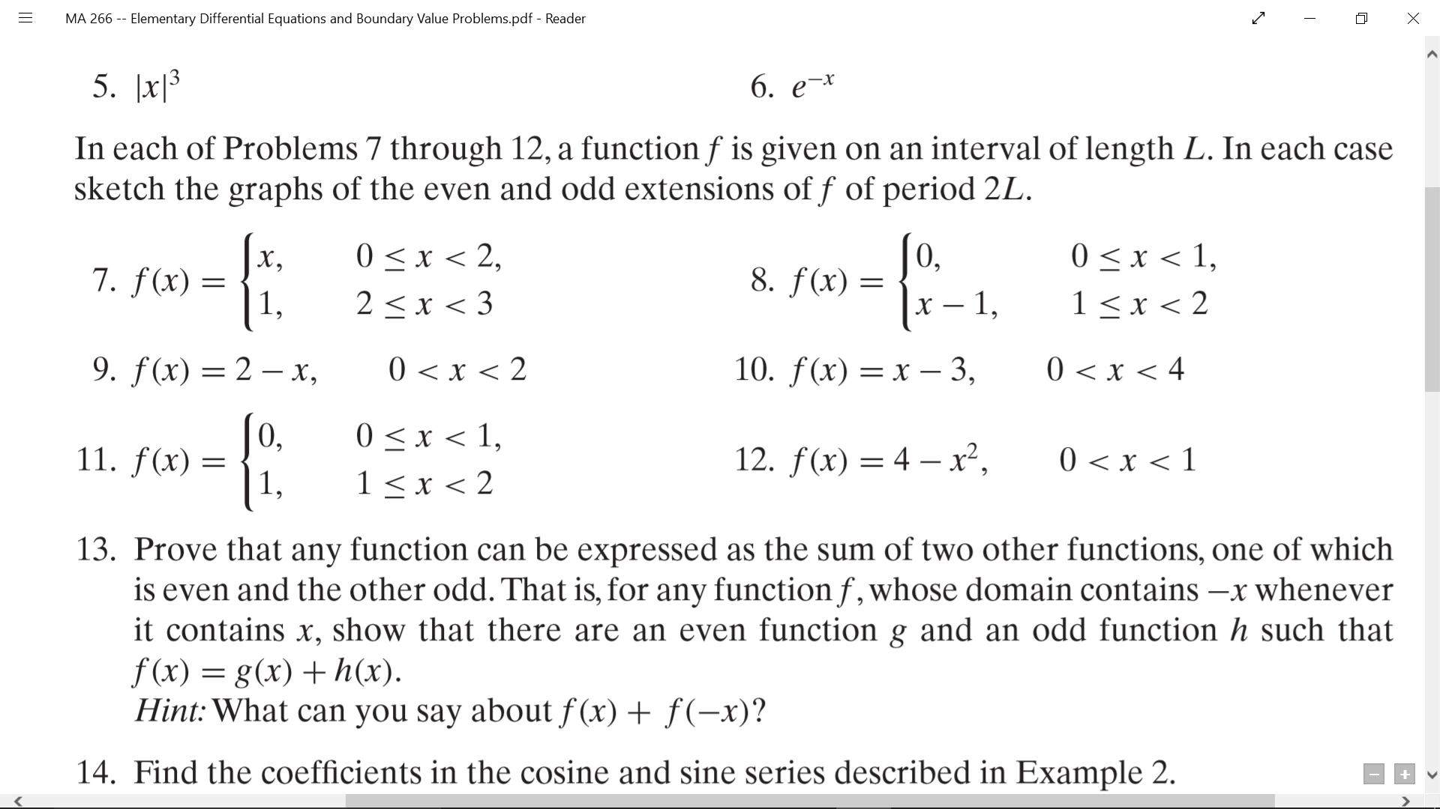

## Section 10.5: Separation of Variables; Heat Conduction in a Rod

### 

### #1

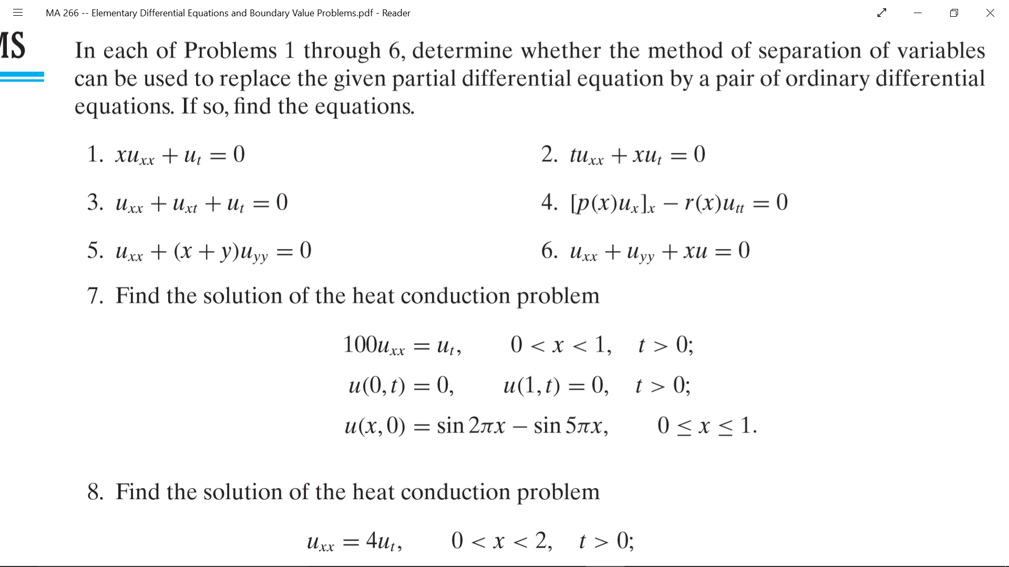

### #5



## Section 10.6: Other Heat Conduction Problems

### 

### #2

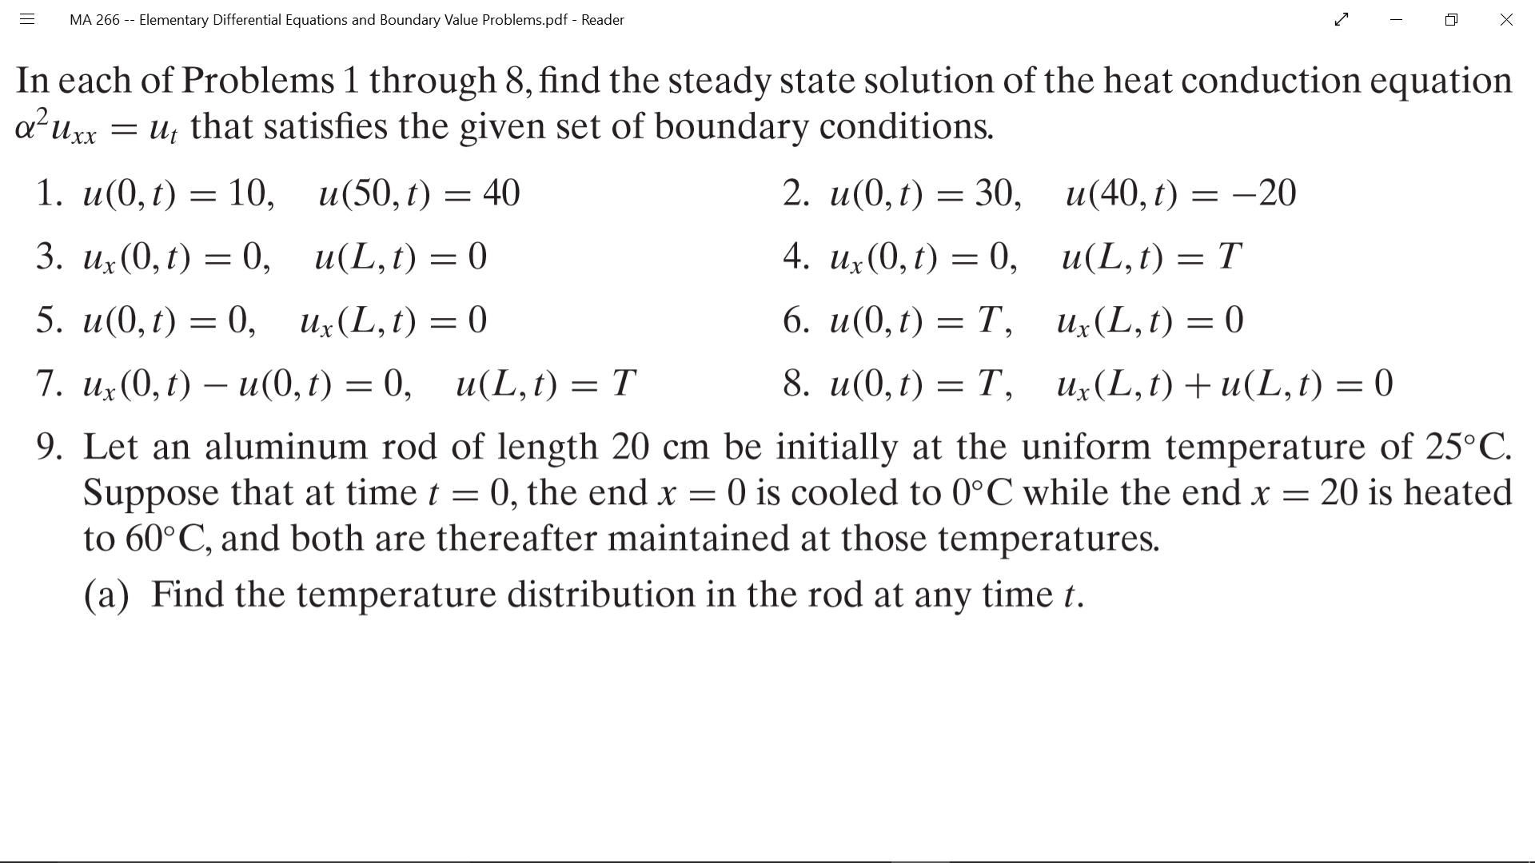

## Section 10.7: The Wave Equation: Vibrations of an Elastic String

### 

### #5(a)

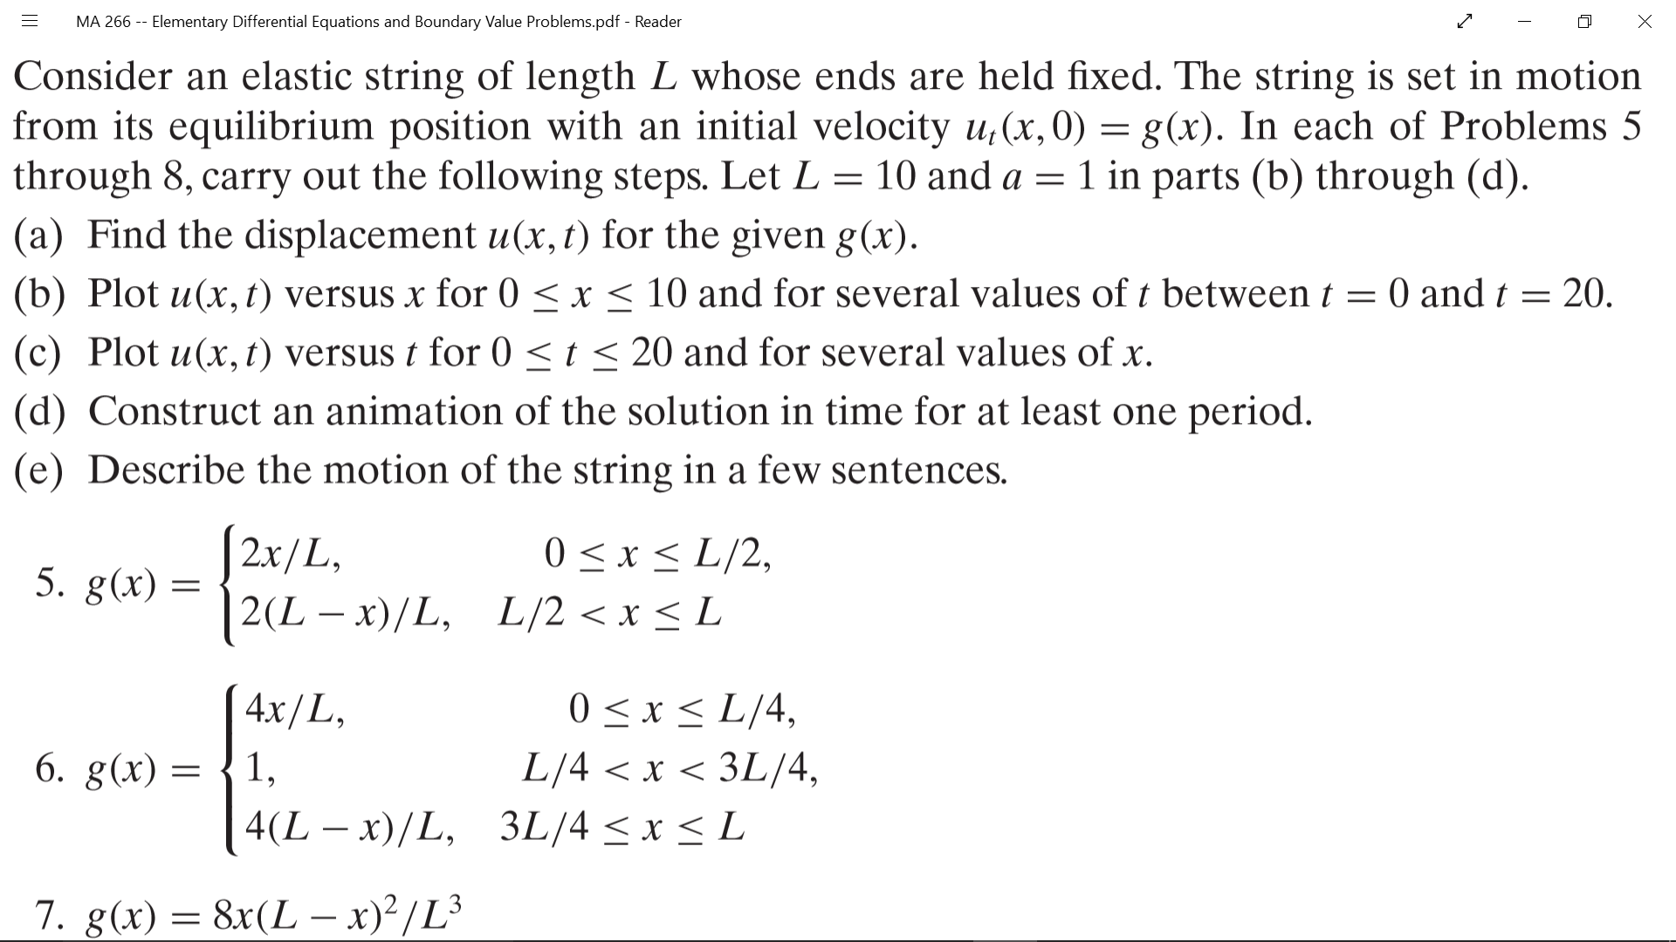

## Section 10.8: Laplace’s Equation

### #1(a)

